Executive Summary

Goal & Scope
Week 2 delivered a secure, role-based foundation for the Course Enrollment System, focused on user authentication, course creation, student enrollment, and basic admin oversight, using only core academic entities.
Key Achievements:
- Security: Full Role-Based Access Control (RBAC) with method-level security and stateless session management.
- Scheduling: Robust classroom scheduling with double-booking prevention and capacity validation.
- Enrollment Logic: Automated waitlist handling; when a student drops a course, the next student on the waitlist is automatically promoted.
- Attendance: Lecturers can record attendance with strict data integrity (one record per student/session).
- Infrastructure: Complete database schema versioning via Flyway (Migrations V1–V4).

Technologies
- Backend: Spring Boot, Spring Security (Stateless/JWT), Spring Data JPA
- Frontend: Thymeleaf, Tailwind CSS, JavaScript
- Database: MySQL with Flyway Migration
- Tools: Maven, Git, Postman

Team Roles and Contributions
Role | Team Member
Security & Authentication Lead | David
Student Features | Rasy
Lecturer Features | Hour
Admin Features | Seyha
Database & Infrastructure | Rith

System Overview
The Course Enrollment & Classroom Scheduling System is a web-based academic management platform designed to streamline course registration, scheduling, and role-based interactions among Students, Lecturers, and Administrators. Built using a classic Spring Boot layered architecture, the system ensures separation of concerns, testability, and maintainability.
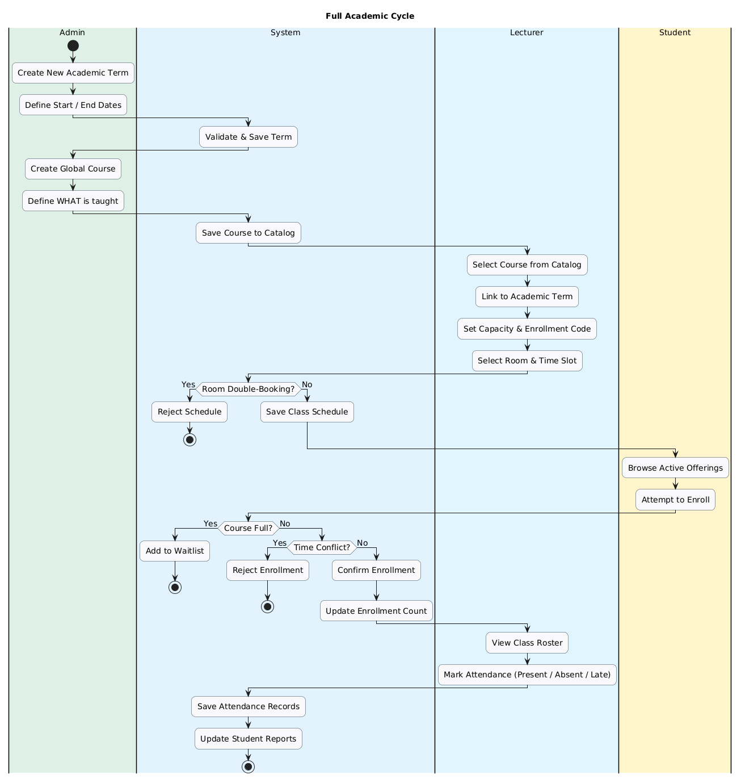

Core Modules Delivered
- Administrative Core: Centralized management of Users, Academic Terms, Rooms, and the Global Course Catalog (ensuring a standardized curriculum).
- Course Offerings: Lecturers manage class instances (Offerings) by selecting existing courses from the catalog and assigning them to specific terms, rather than creating courses from scratch.
- Scheduling Engine: Validation logic enforces conflict checks to prevent room double-booking and ensures room capacity accommodates the class size.
- Enrollment Engine: Automates capacity management by triggering Waitlist placement for full courses and executing auto-promotion when seats become available.
- Attendance System: Tracks student presence (Present, Absent, Late) per class session with access controls restricted to the assigned lecturer.

Key Characteristics
- User Roles:
  - Student: Browse courses, enroll, view schedule
  - Lecturer: Create courses, assign schedules, record attendance
  - Admin: Manage academic terms, rooms, and system metrics
- Core week 1 & 2 Scope: Authentication, course creation, enrollment, and role-based dashboards
- Data Integrity: Enforced via MySQL constraints and Flyway-managed schema
- Security: Role-based access at URL, method, and UI levels
- UI: Responsive, server-rendered with Thymeleaf + Tailwind CSS

High-Level Architecture
The system follows a clean 5-layer architecture, from user interface down to persistent storage:
- UI Layer: Renders responsive HTML pages using Thymeleaf templates; handles user input and displays feedback.
- Controller Layer: Receives HTTP requests, validates input, and delegates to services; returns view names or redirects.
- Service Layer: Contains core business logic (enrollment rules, validation, waitlist promotion); transactional boundary.
- Repository Layer: Manages data access via JPA; abstracts SQL interactions.
- Database Layer: Persistent storage using MySQL with enforced constraints (unique keys, foreign keys, checks).

Requirements Specification

Functional Requirements
- User Login: Students, Lecturers, and Admins log in securely and are redirected to their specific role-based dashboard.
- Create Course: Lecturers can create course offerings with validation for course codes (like GIC25DB), capacity, and term assignment.
- Class Scheduling: Lecturers can schedule classes (Day/Time/Room). The system prevents double-booking rooms.
- Enrollment & Drops: Students can enroll in available courses with enrolment code. They can also drop a course, which triggers a status update.
- Automated Waitlist: If a course is full, students are added to a waitlist. Crucially, if an enrolled student drops, the system automatically promotes the next waitlisted student.
- Attendance Tracking: Lecturers can record student attendance (Present, Absent, Late) for specific class sessions.
- Admin Management: Admins manage infrastructure (Rooms, Academic Terms) and view system-wide metrics.

Non-Functional Requirements
  - Secure: Users only see features for their role.
  - Reliable: Data rules (like unique course codes and capacity limits) are enforced.
  - Maintainable: Database changes use Flyway; code is reviewed before merging.
  - User-Friendly: Clear messages (like “Added to waitlist”) appear after actions.

Database Design

Entity-Relationship Diagram (ERD)
The system uses a normalized 12-table relational schema designed to support flexible course offerings, multi-lecturer assignments, waitlists, scheduling, and attendance. The core structure separates reusable definitions (like courses) from term-specific instances (course_offerings) and physical resources (rooms).
Key Constraints Added:
  - uk_schedule: Prevents room conflicts (Room + Day + Time).
  - uk_attendance: Ensures one attendance record per student per session.
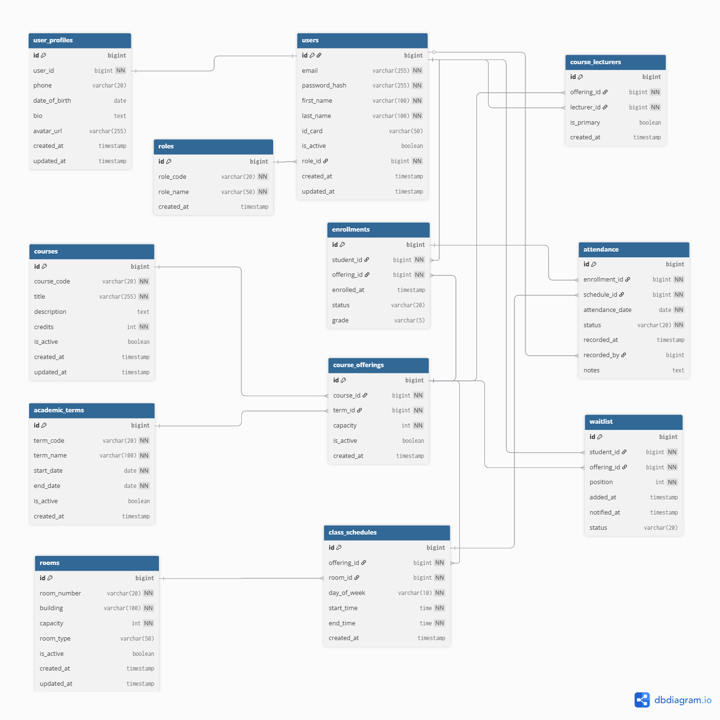

System Architecture & Design

Component Diagram
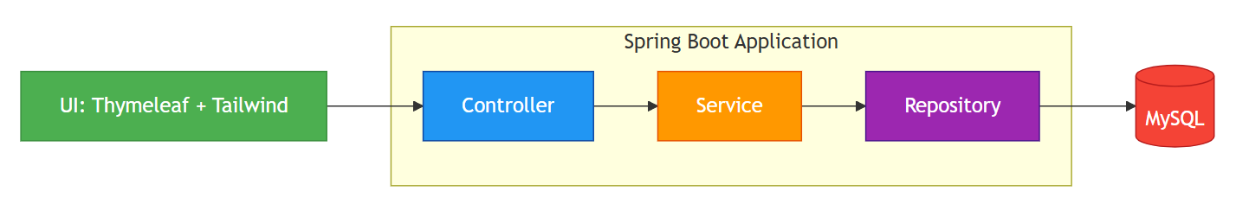

Sequence Diagram: Student Enrollment Flow
This diagram captures the core Sprint 1 workflow: a student enrolling in a course, including capacity check and automatic waitlist fallback.
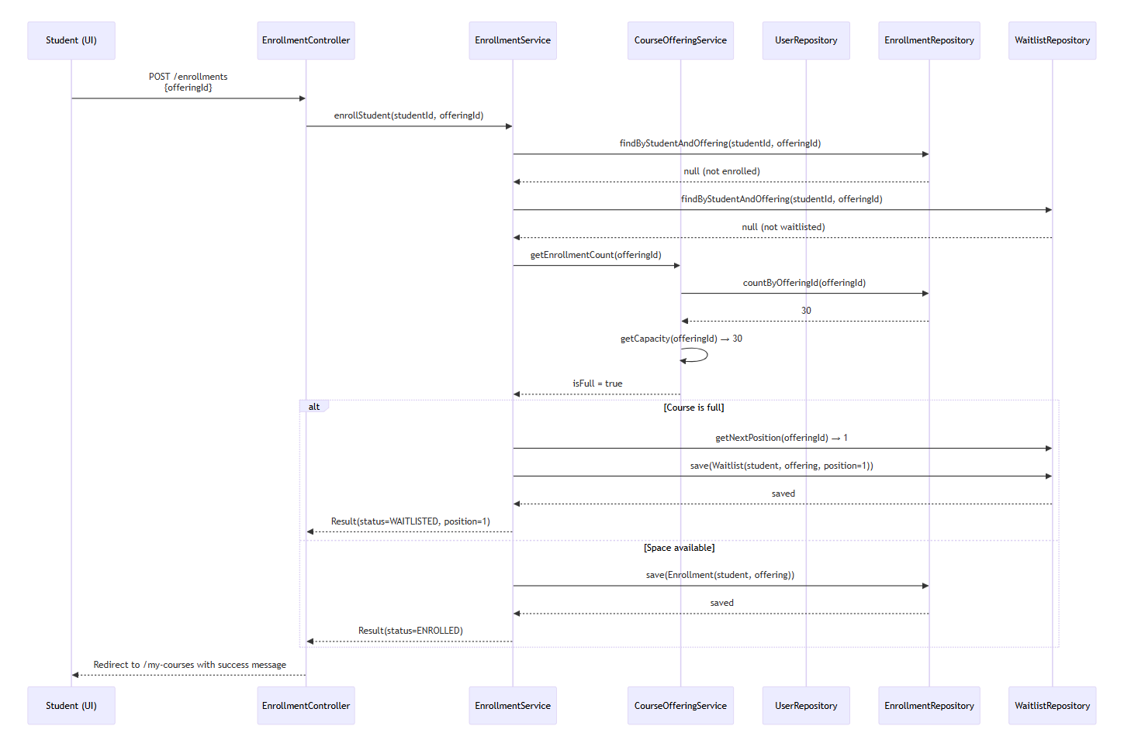 Rules Enforced:
- No duplicate enrollment/waitlist
- Capacity check → auto waitlist
- Atomic save operation

Sequence Diagram: Lecturer Course Creation
This diagram shows how a lecturer creates a course offering in an active academic term, with auto-assignment of lecturer and code validation.
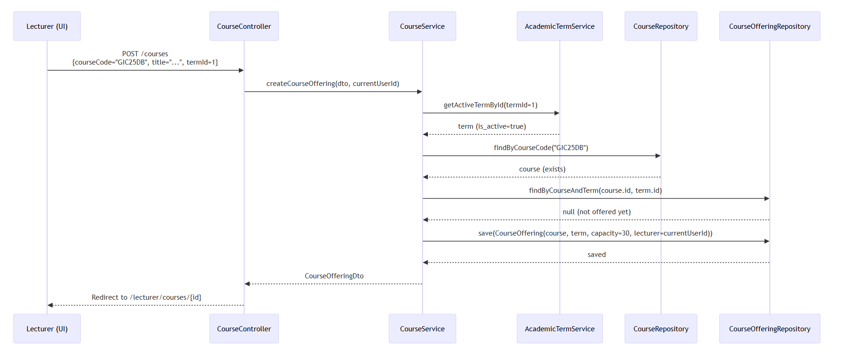

Security Implementation

Authentication Flow
- User Login:
  - Users authenticate via email/password at /api/auth/login.
  - Credentials are verified against the users table.
- Token Generation:
  - On success, the server generates a JWT (JSON Web Token) containing the user's email and role_id.
  - This token is returned to the client and stored (like LocalStorage/Cookie).
- Stateless Request Processing:
  - Every subsequent HTTP request includes the JWT in the Authorization header.
  - The JwtFilter intercepts requests, validates the token, and sets the Spring Security context (Stateless Session).

Data & Password Security
Aspect | Implementation
Password Storage | BCrypt hashing (BCryptPasswordEncoder) with strength 10.
Sensitive Data | Stateless (No server-side session storage), reducing server memory load.
CSRF Protection | URL-based (.requestMatchers()) and Method-based (@PreAuthorize) security.
SQL Injection | Prevented via Spring Data JPA repositories and parameterized queries.

UI/UX Design
The user interface is built with server-rendered Thymeleaf templates and styled using Tailwind CSS (via CDN). The design follows a component-based approach, promoting reuse and consistency.

Design Principles
- Role-Centric Views: Security tags (sec:authorize) hide elements dynamically. A student never sees "Take Attendance" buttons.
- Visual Scheduling: Time blocks are rendered in a grid format rather than simple lists.
- Feedback Loops: Toast notifications appear for "Waitlist Joined" or "Attendance Saved".

Key Screens (week 1-2)
🎓 Login Page
- Clean form with email/password fields
- Error display for invalid credentials
- University-branded header
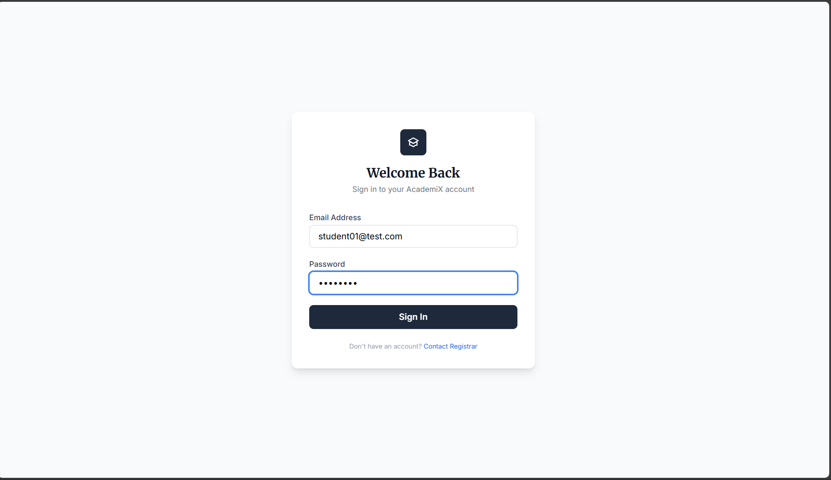
👨‍🏫 Lecturer Dashboard
- My Courses: List of active courses.
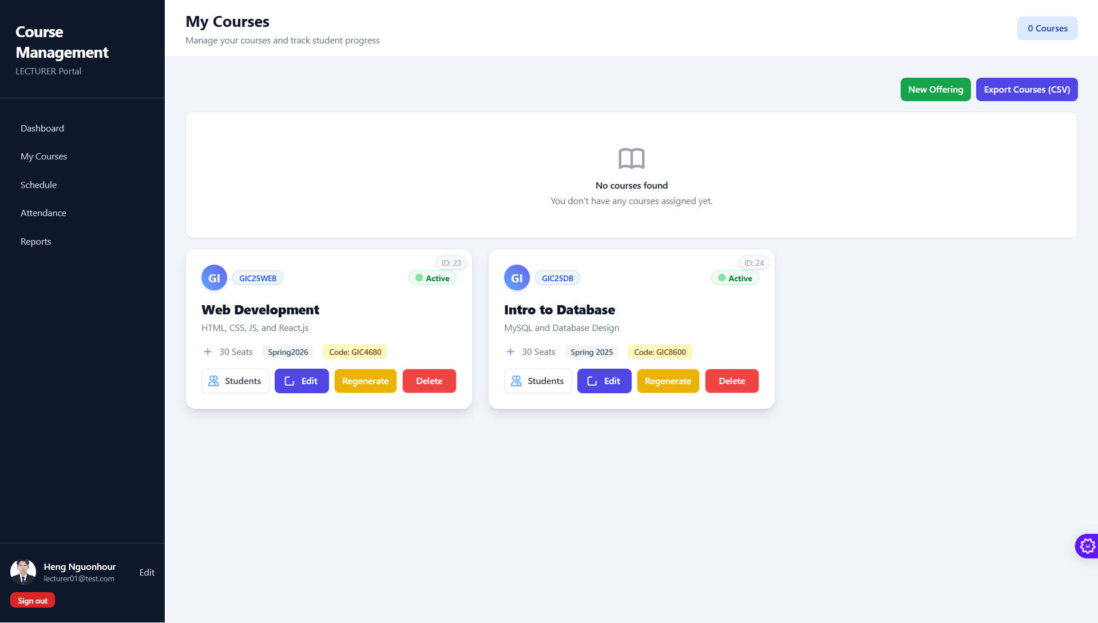

- Schedule Manager: Form to assign rooms/times with conflict error handling.
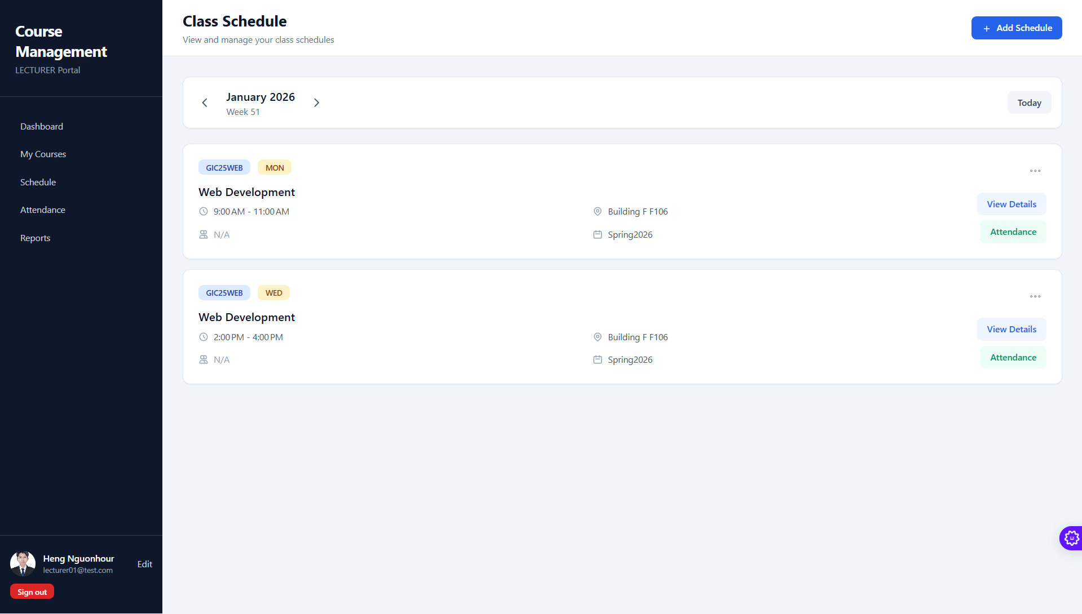
- Attendance Sheet: Table view of students with radio buttons for status (Present/Absent).
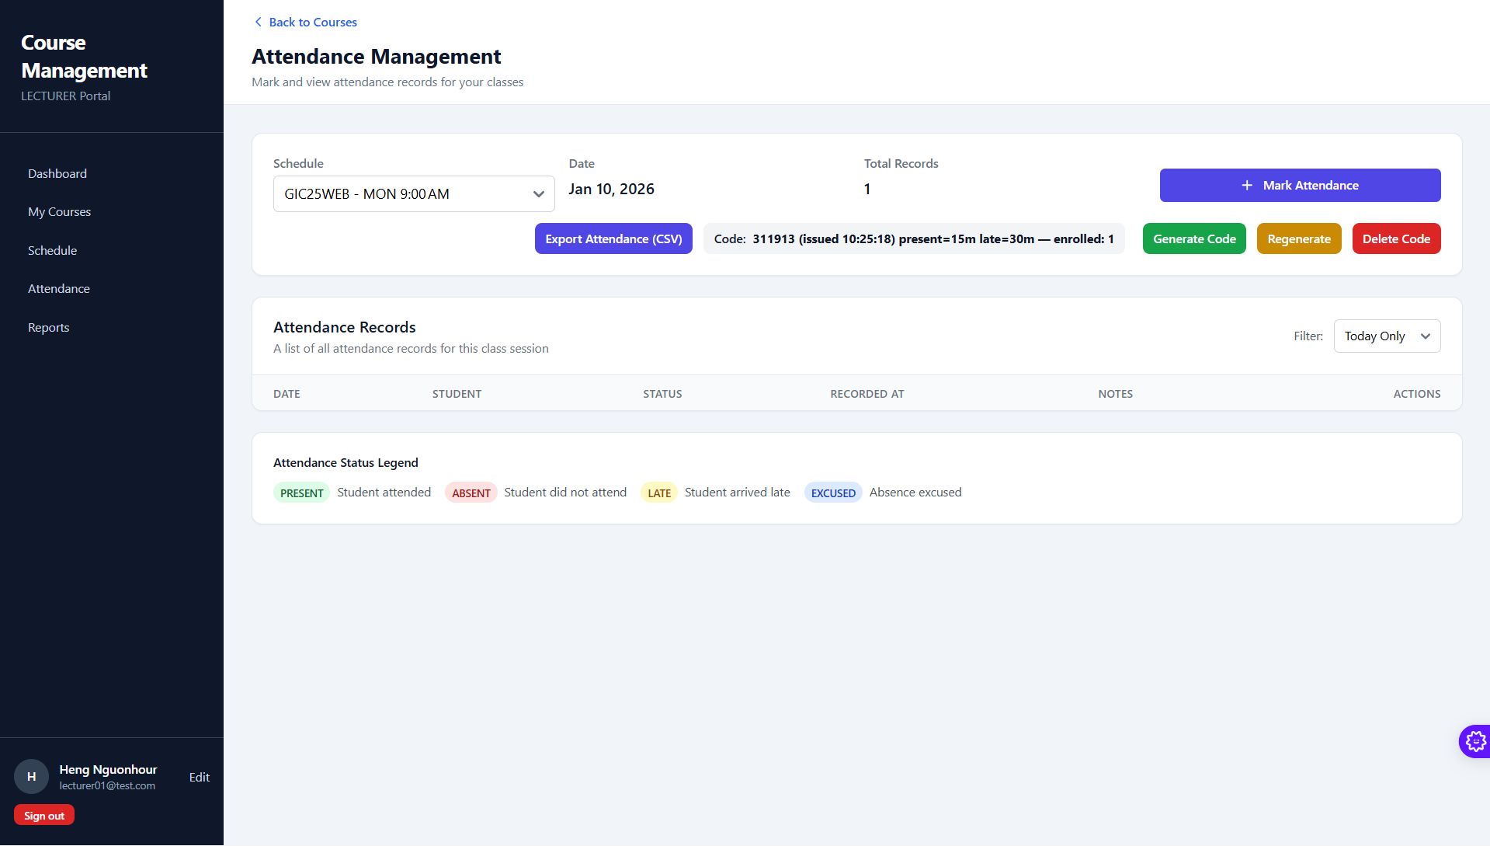
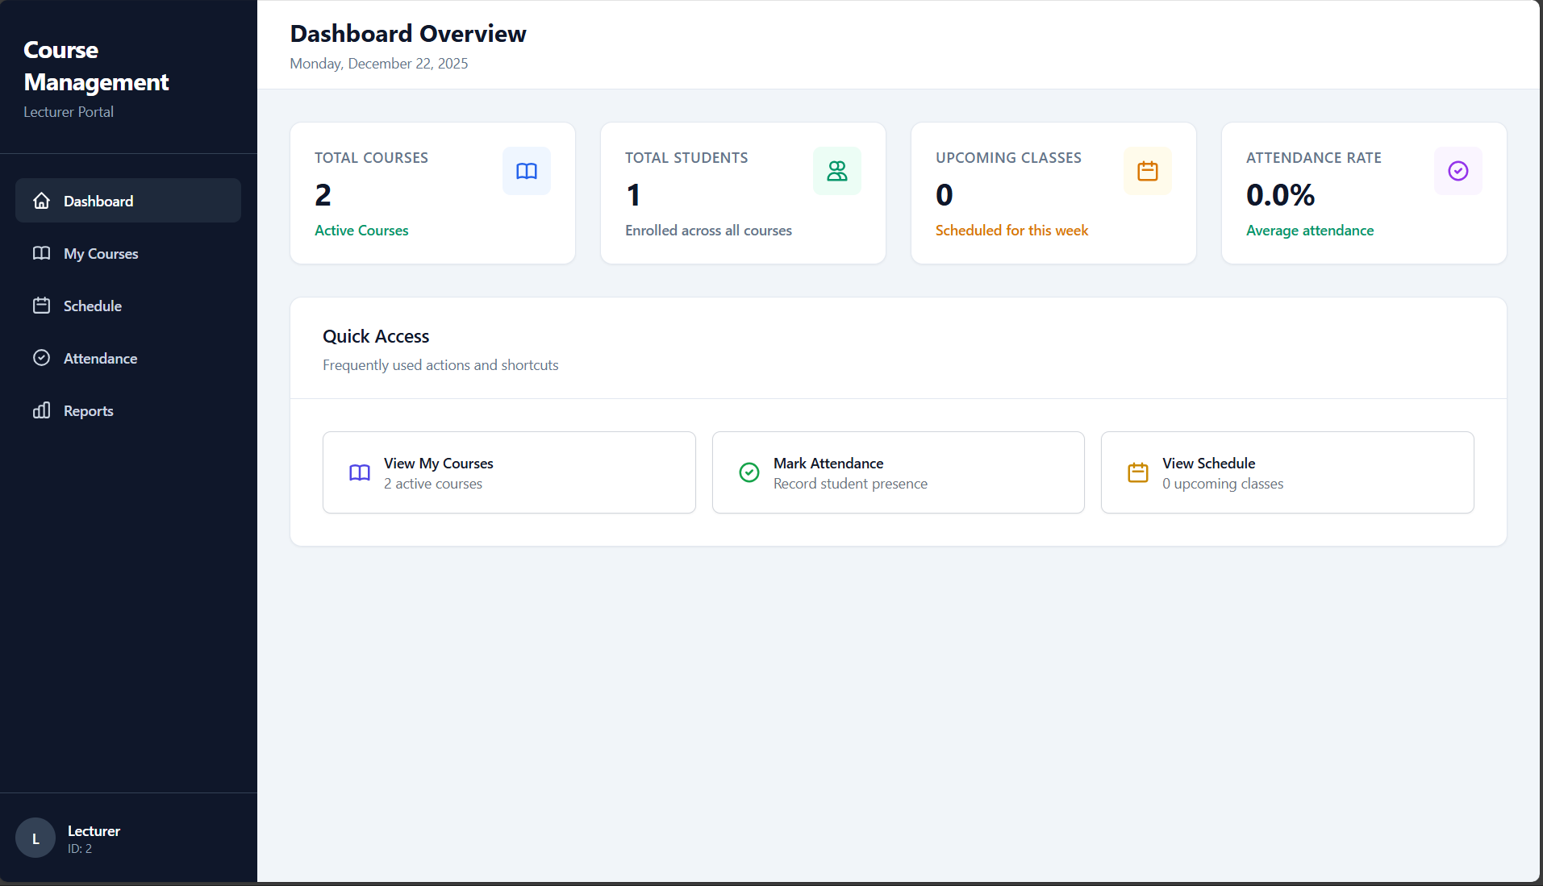
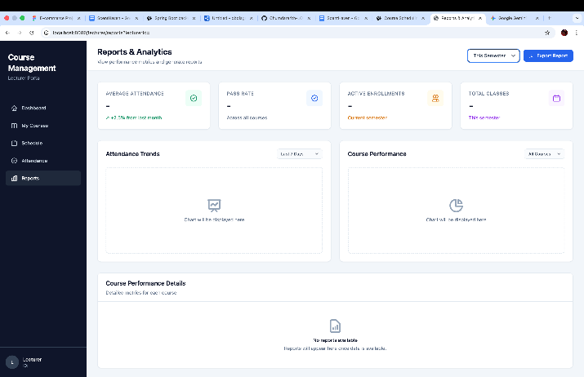
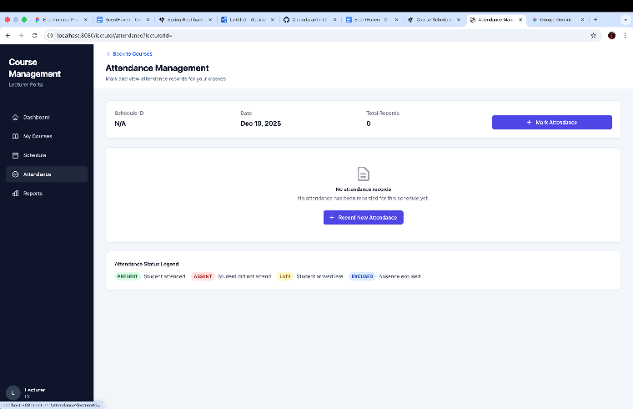

👩‍🎓 Student Dashboard
- Course Catalog: Grid of available courses in active term
- My Courses: List of enrolled courses (status: “Enrolled”)
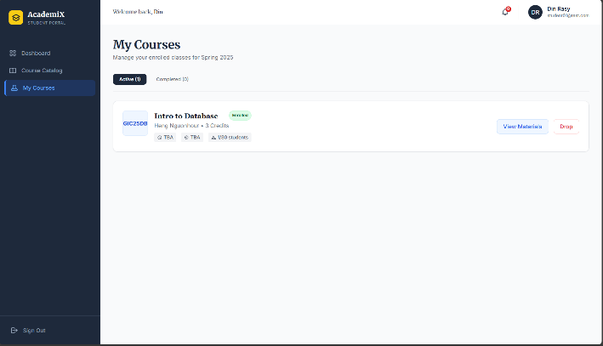
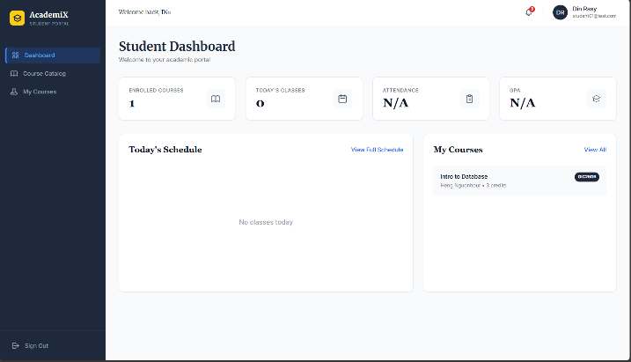
- Empty states: “No courses yet” illustration with CTA
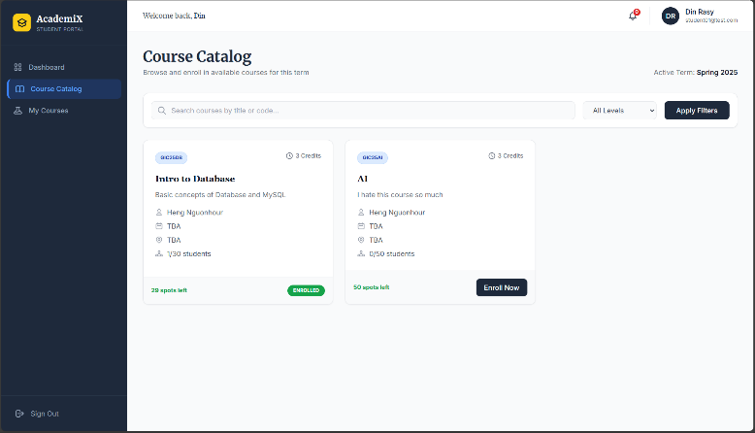
👔 Admin Dashboard
- Metrics cards: Total Students, Lecturers, Courses, Active Terms
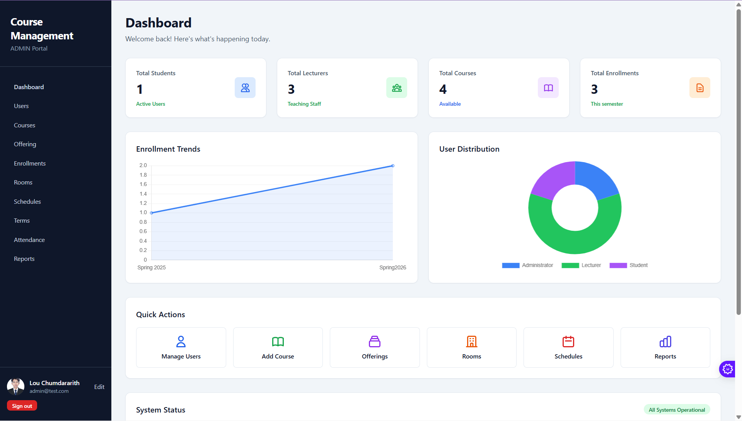
- Secure access (403 if non-admin)
- Navigation stubs for future term/room management

Development Process
Our team followed an agile, collaborative workflow over Sprint 1 (8 – 22 December 2025).

Team Structure & Responsibilities
Role | Member | Focus Area
Security & Authentication Lead | David | Method-level security, JWT implementation, CSRF, Login/Logout logic.
Main Entity CRUD Developer | Rasy | Enrollment rules, Drop logic, Waitlist Auto-Promotion engine.
Secondary Module CRUD Developer | Hour | rooms, class_schedules, attendance (Sprint 2 prep)
Admin Developer | Seyha | Admin dashboard, role-based UI, system metrics, Thymeleaf layout
Database & DevOps Lead | Rith | MySQL schema, Flyway migrations, seeding, dev setup

Git & Code Review Workflow
We adopted a dual-commit review strategy to ensure quality before merging:

Draft Commit
- Developer implements a logical unit of work (like “build admin dashboard UI”)
- Pushes commit with [REVIEW] draft: ... message
- Notifies team for inspection

Peer Review
- At least one teammate tests the feature and checks code quality
- Feedback is given via Git comments or direct discussion

Official Commit
- After approval, developer amends the draft commit with a conventional message
- Example:
  - Draft: [REVIEW] draft: create admin dashboard with user counts
  - Official: feat(admin): implement admin dashboard with system metrics

Merge to main
- Only official commits are merged via pull request
- No draft commits remain in the final history
Result: Clean, professional Git history with full team participation.

Branching Strategy
Branch Type | Example | Purpose
main | main | Protected — stable, deployable code
Developer’s Name | Lou-chumdararith | For each user tasks — one per task card
develop | release/sprint-1 | Final integration branch (optional)
- All work done in feature branches
- Merged to develop only after review and approval
- main always passes mvn spring-boot:run with empty DB

Tools & Technologies
Category | Tools
IDE | IntelliJ IDEA, VS Code, MySQL Workbench
Backend | Spring Boot 3.3, Spring Security, Spring Data JPA
Frontend | Thymeleaf, Tailwind CSS (via CDN)
Database | MySQL 8.0, Flyway, HikariCP
Build | Maven
Version Control | Git + GitHub
Diagrams | dbdiagram.io, Mermaid, Plant UML

Appendices

Appendix A: Full ER Diagram (Sprint 1 Schema)
Figure A1: Complete Entity-Relationship Diagram showing all 12 tables and relationships. Generated using dbdiagram.io.
🔗 View/Edit Online: https://dbdiagram.io/d/6898a585dd90d17865441dfa

Appendix B: Sample Flyway Migration (V1__init_schema.sql)
E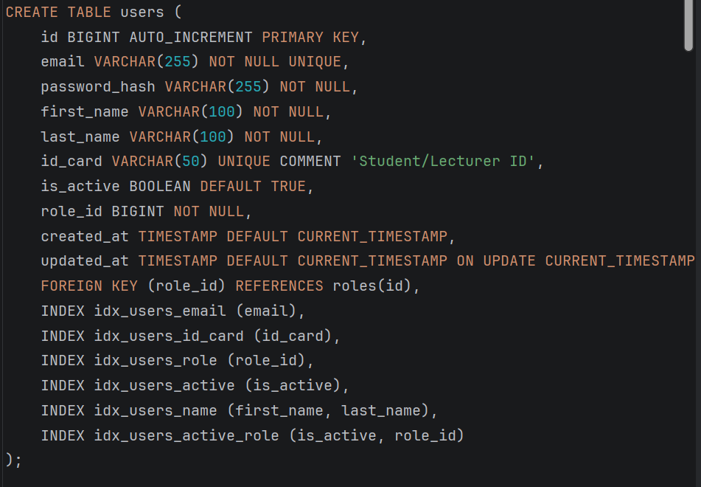

Appendix C: Key API Endpoints
Method | Endpoint | Description | Role
GET | /login | Login page | Public
POST | /login | Authenticate user | Public
GET | /student/catalog | View available courses | STUDENT
POST | /enrollments | Enroll in course | STUDENT
GET | /lecturer/courses | View my courses | LECTURER
GET | /lecturer/courses/new | Show course creation form | LECTURER
POST | /courses | Create course offering | LECTURER
GET | /admin/dashboard | Admin metrics dashboard | ADMIN

Appendix D: Team Member Contributions (week 1-2)
Member | Key Deliverables
David | Spring Security config, role-based redirects, login/logout, sec:authorize integration
Rasy | Course, Enrollment, Waitlist entities/services, capacity logic, duplicate prevention
Hour | Room, ClassSchedule, Attendance entity design; scheduling conflict rules (Sprint 2 prep)
Seyha | Admin dashboard, Thymeleaf layout, role-aware UI fragments, responsive design
RITH | Full Flyway migrations (V1–V2), MySQL setup, seed data, report documentation

